**Contents**

1. Setup………………………………………………………………………………………………………………………………………….1
2. Neural Networks………………………………………………………………………………………………………………………2-4
3. Convolutional Neural Network (CNN)…………………………………………………………………………………….5-9
4. Long-Short Term Memory (LSTM)……………………………………………………………………………………….10-11
5. Data Preparation…………………………………………………………………………………………………………………12-13
6. Hyper-Parameter Setting for CNN & LSTM………………………………………………………………………………14
7. Performance Stats & Graphs…………………………………………………………….………………………………15-26
8. Conclusion……………………………………………………………………………………………………………………………..27

**Setup**

Install Anaconda with Jupyter Notebook. Open Anaconda PowerShell and do create new environment

* conda create –name tf-gpu4
* conda activate tf-gpu4
* conda install tensorflow (or conda install tensorflow-gpu)
* Jupyter Notebook

Open Jupyter Notebook and install Keras, numPy etc.

Optionally tensor board can also be installed which allows to summaries and compare different setting on the same model.

* Conda activate tf-gpu
* Pip show tensorflow
* Cd location of tensorflow
* Cd tensorboard
* Python main.py –log dir=/path to folder of event files
* Jupyter notebook

**Neural Networks**

The heart of neural network are neurons which attempts to extract features from explanatory variables to explain the variation in the response. A neuron consist of simple equation consisting of weights and bias to which an activation function is applied. This activation function allows the neural network to understand non-linear relationship.

Activation function (weight * X + Intercept)

A good activation function should have these properties:

1. Should be differentiable with respect to X such that small changes in values of X results in Y values to change significantly.
2. Should be non-linear in nature so to capture complex non-linear relationship in data.

In the starting weights and bias are initialized at random and when the train data is passed through the network the weights and bias are updated through backward propagation through time i.e. through gradient descent the network learns how to optimize its connections (weights/bias) to fit the data.

$$\frac{d(loss)}{d\left(weights\right)}*learning rate$$

The above equation means the effect of changing the weights will have the loss. Learning rate is a parameter chosen by the user that controls how much the weights are changed in response to the error observed. If the learning rate is too small gradient descent will be slow to reach the minimum while if the learning is too high, the gradient descent might miss the minimum.

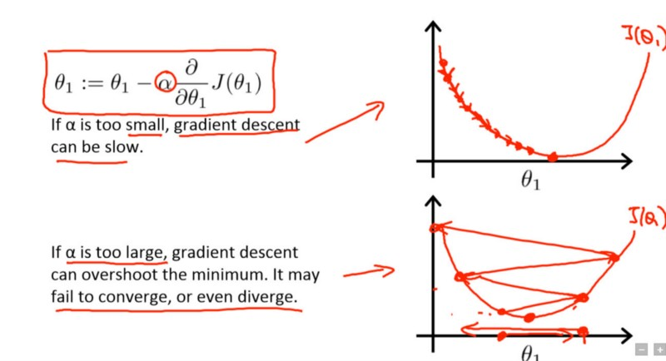

There are many options available to optimize the network including Sigmoid, Tanh and ReLu.

Sigmoid:

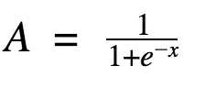

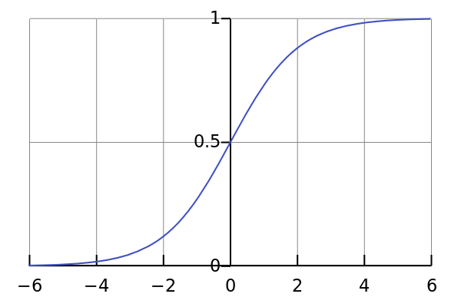

Advantage: non-linear plus for values of X between -2 and 2 result in significant change in Y. Output range from 0 to 1.

Disadvantage: At the end points changes in Y very small in respond to change in X. Meaning Gradient is very small so network cannot learn further. This is called the vanishing gradient problem.

Tanh:

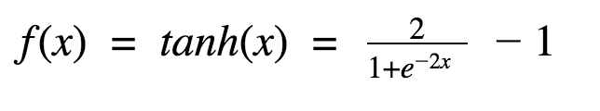

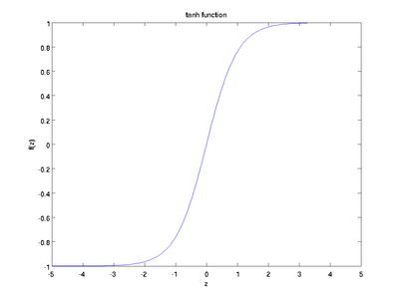

Similarly to Sigmoid but has advantage that gradient descent will be stronger since change in X result in larger changes in Y compared to sigmoid. Output range from -1 to 1. Still suffers from vanishing gradient at the end points.

ReLu:

A(x) = max (0, x)

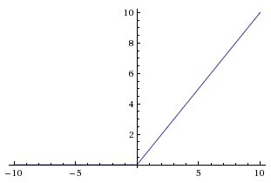

Advantage: nonlinear and no vanishing gradient for positive x.

Disadvantage: Dead ReLu units for negative x as there is no change in Y for negative values f x.

**Vanishing/exploding gradient** ― the vanishing and exploding gradient phenomena are often encountered in the context of RNNs. The reason why they happen is that it is difficult to capture long term dependencies because of multiplicative gradient that can be exponentially decreasing/increasing with respect to the number of layers.

While training data is passed in pieces called **batches**. The lower the batch count the better the model understand the data but more stress on CPU/ GPU. Once all the training data is passed through several batches one **epoch** is complete. Data can passed many times and the # of epoch will increases.

There are many optimizer that can calculate the gradient descent. Popular ones include Adam, RMSprop etc. They differ in the way they update the weights and bias.

The number of neurons within a layer and the layer can be specified by the user. However deeper layer and very high neuron risk overfitting while shorter layer and less than ideal number of neurons results in under fitting the data. **Dropout rate** can be used to avoid overfitting as it randomly drops some neuron from the model.

Common terms:

**Dense layer** contains input layer + hidden layer.

**Verbose**-> how many # of output to see.

**Early Stopping** -> To avoid overfitting, the test error on a validation set could be monitored while training the model for each epochs and can stop training if test and train error both stop reducing. This is done by specifying the desired amount of loss you want to see reduced in each epoch. Patience describes for how many epochs to wait before stop training the model.

**Loss**: A function to minimize during gradient descent. Could be Mean Absolute Error, Root Mean Squared Error.

**WaveNet (CNN)**

A convolution is a mathematical combination of two function to produce a third function. In CNN, convolution is performed between the input variable X and weighted matrix called a filter to produce an output. The filter slides across the input where at each location /time step, the product between each element of the filter and the input is computed and summed up to obtain the output at the current location. If there are multiple inputs, each of them will be convolved with a new filter to produce an output. These outputs are called the feature maps. To achieve non linearity usually a ReLu activation is applied to these feature maps before being passed to the next layer.

The size of these feature map depend on certain properties of the filter and the input variable.

For example if the input is 7 *7 and there are 10 filter each of size 3*3 and stride is of size 1. Then the output will be of size 5*5*10. Stride controls how much the filter move at a time. Generally the size of the output can be calculated using this formula:

$$Output size=\frac{input size-filter size}{stride }+1$$

It can be observed above that the output size is smaller than the input size. If there are many convolution layers the output size will reduce significantly. To avoid this loss of information, padding is generally used. Padding ensures that the output size is same as the input size. If padding is used then the above formula becomes:

$$Output size=\frac{input size-filter size+2*padding size}{stride }+1$$

For example if the input is 7 *7 and there are 10 filter each of size 3*3 and stride is of size 1 and padding of 1, then output size is 7*7*10.

The number of parameter after each convolution i.e. number of weights and bias can also be calculated.

Example: Conv1D with 32 filters with size 2*1 with stride 1. The number of parameter is 96 parameters. The plus 1 is the formula below is for the bias term.

$$\# of parameter=\left(\left(filter width*filter height\right)+1\right)*\# of filters$$

In the starting like any other neural network filters are initialized with random values and during gradient descent via backpropagation through time, optimal values of weights and bias are found.

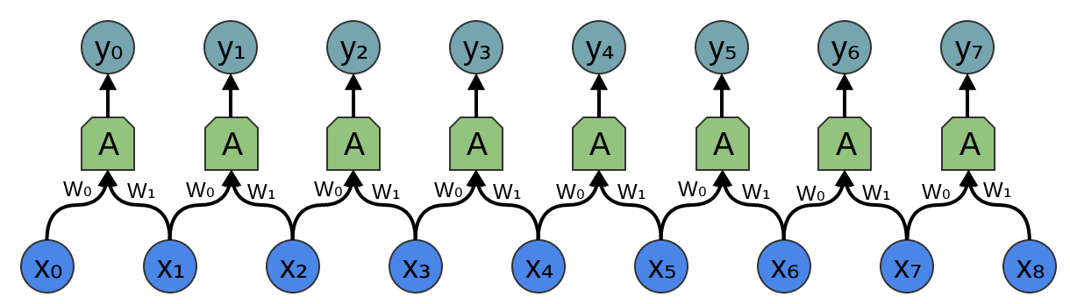

The above image highlight the issue of using the future to predict the past as X1 is used to predict Y0 and so on. To avoid this we block our convolution from using the future input and only allow inputs to connect to future time step in a casual structure as described in the image below.

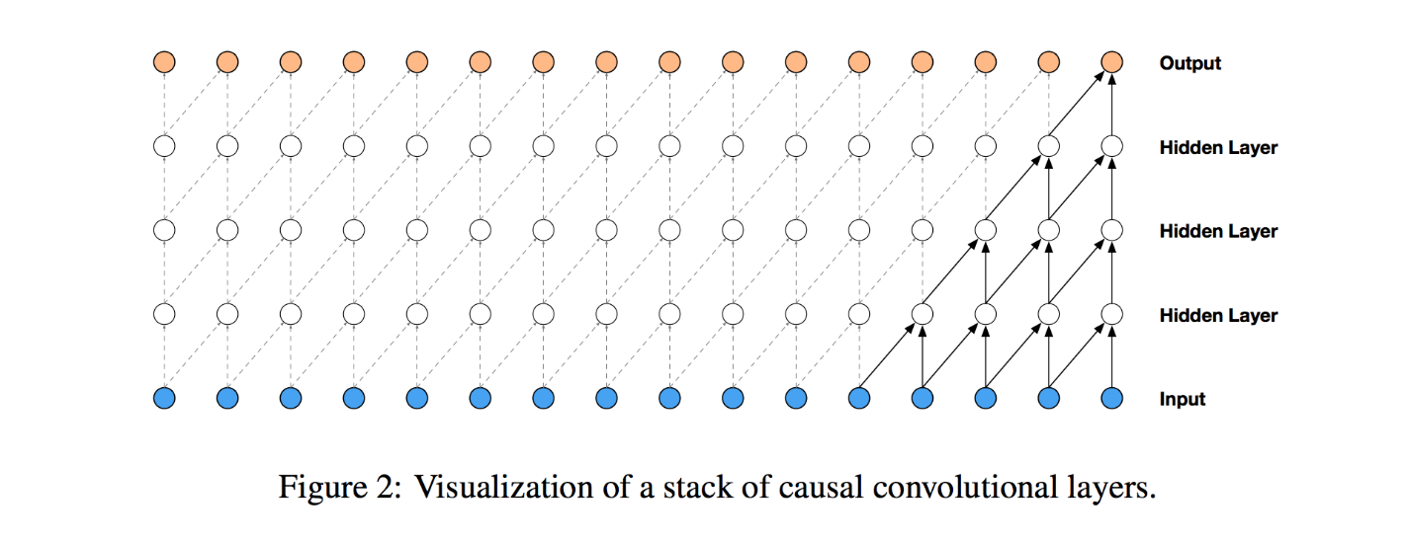

These are called causal convolutions. In Keras library by specifying padding = “causal” we can achieve this. Padding= “valid” means no padding whereas padding=”same” means that the input size is preserved.

To have large access to previous input something called dilated convolutions are used. The idea here is to apply the filter over an area larger than its length by skipping input values with a certain step. The figure above depicts the dilated causal convolutions for dilation 1, 2, 4 and 8.

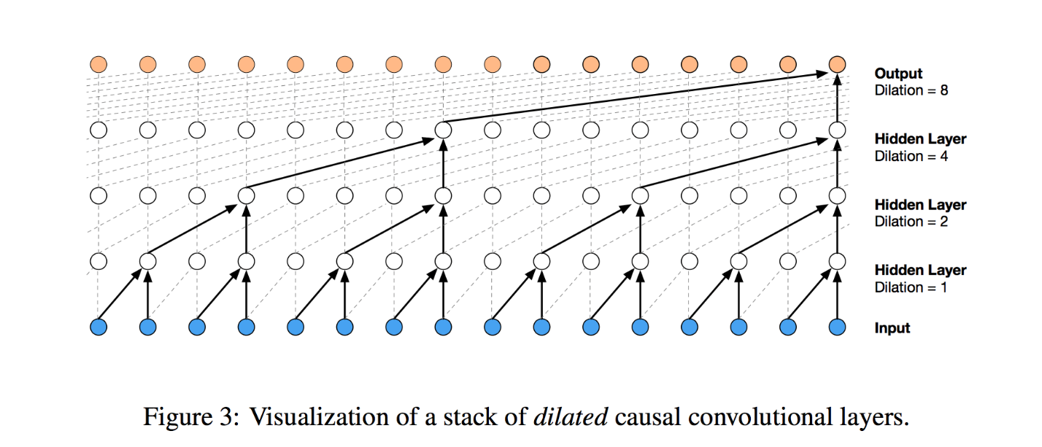

Receptive field is the information that is visible to convolution at a time. It means how much of the previous input variable are available to make a prediction of the current time step. This must be decided before as information outside the receptive field cannot be used to predict the current time step.

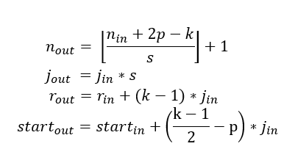

The first equation is same as previously discussed that calculate the output size.

The second equation calculates the jumps the filter makes between convolutions that is the stride size *dilation factor. Since in our case we always use stride size of 1, we have j_out = j_in *1

The third equation calculates the size of the receptive field.

Example: Suppose we have a dilation rate from 1, 2, 4……512. To calculate the size of the receptive field for this block assuming filter size of 2 and stride length 1.

|  |  |  |  |
| --- | --- | --- | --- |
| Layer | Dilation rate | Formula | Size of receptive field |
| 1 | 1 | r-out= 1+ (2-1)*1 | 2 |
| 2 | 2 | r-out= 2+ (2-1)*2 | 4 |
| 3 | 4 | r-out= 4+ (2-1)*4 | 8 |
| 4 | 8 | r-out= 8+ (2-1)*8 | 16 |
| 5 | 16 | r-out= 16+ (2-1)*16 | 32 |
| 6 | 32 | r-out= 32+ (2-1)*32 | 64 |
| 7 | 64 | r-out= 64+ (2-1)*64 | 128 |
| 8 | 128 | r-out= 128+ (2-1)*128 | 256 |
| 9 | 256 | r-out= 256+ (2-1)*256 | 512 |
| 10 | 512 | r-out= 512+ (2-1)*512 | 1024 |

So this block has access to 1024 previous data points for predicting the current time step.

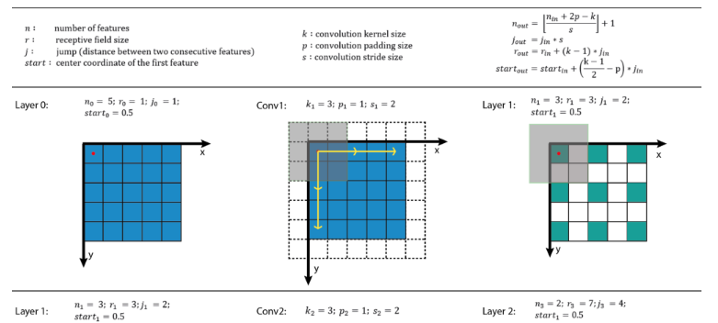



The architecture of CNN used here is based on Wave Net which is used for audio generation. The meaning of causal and dilated convolution is explained below.

A block/ residual block is the boxed portion in the diagram. A residual block consist of **gated activations, skip** and **residual connections.**

Gated Activations are used to keep relevant past information and forget unnecessary information from past time steps. Gates contains sigmoid activations. A **sigmoid activation** is similar to the tanh activation. Instead of squishing values between -1 and 1, it squishes values between 0 and 1. That is helpful to update or forget data because any number getting multiplied by 0 is 0, causing values to disappears or be “forgotten.” Any number multiplied by 1 is the same value therefore that value stay’s the same or is “kept.” The network can learn which data is not important therefore can be forgotten or which data is important to keep. **Tanh function** are used to regulate the range of values in the network.

$$z=\tanh\left(W_{i}*x\right) * σ(W_{g}*x)$$

When sigmoid and tanh output is multiples, the network keeps the values its think are relevant in the **receptive field** and squish them between -1 and 1 for used in the current prediction.

In a neural network input is usually feed into a layer and then into another layer and so on until the output. This means early layers influence deeper layers via a hierarchy of intermediate connections. The reasoning behind **skip connections** is what if these lower-level signals are immediately useful for predictions and may be at risk of distortion as they are passed through a complex hierarchy of computations. That’s why skip connections are used in the above diagram where in each residual block after the gated activation the convolutions are passed to the penultimate convolution to preserve these low-level signals.

**Residual connections** are just like skip connection. In the diagram above, in each residual blocks the input bypass the gated activations unit and then are later added to the gated activation unit output. The effectiveness of residual connection is not fully understood but they facilitate the use of deeper networks by allowing for more direct gradient flow in backpropagation.

There are different connections at different point in the network. Called **residual connections, gate connections, and penultimate connection**. For each connection, optimal number of filters and filter width must be decided for best results. However for calculation of receptive field it is the gated connection’s filter width that must be used.

Number of **layers** refers to the number of hidden layer used in the gate connections or the amount of dilation used. **Stacks** refers to replicating residual block where the output of one residual block is feed into another. For example: dilation rates =[1,2,4,8,16,32] *2 means 6 layers are used with 2 stacks.

$$Receptive field size ={ filter width}^{\# layers}*\# stacks$$

**LSTM**

**Below the way LSTM works-> forgets the irrelevant past, adds useful information to the present from the past and then prepare for the future from the updated present is highlighted for 1 layer.**

Sigmoid function-> useful for determining whether to keep previous information or not.

Tanh- > mainly used to push values between -1 and 1 to regulate the magnitude of the values.

**Step 1:**

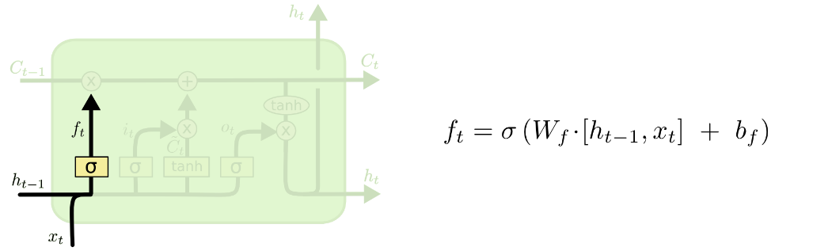

The current input x_t and previous hidden state information h_t-1 are combined and fed into the sigmoid function where it outputs a value between 0 and 1 i.e. f_t. Value close to 0 are forgotten while value close to 1 are kept by multiplying them with the previous cell state i.e. f_t * C_t-1.

**Step 2:**

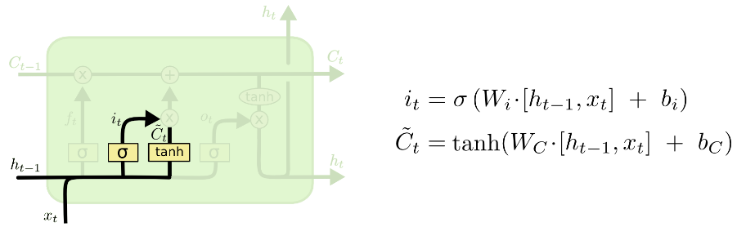

To update the cell state with new relevant information:

First the current input x_t and previous hidden state information h_t-1 are combined and fed into the sigmoid function i.e. i_t. Second the current input x_t and previous hidden state information h_t-1 are combined and fed into the tanh function i.e. C_t. The tanh function creates a vector of new candidate values C_t that could be added to the state while sigmoid decides which values to update. In the next step, these are combined to create the new cell state i.e. C_t * i_t.

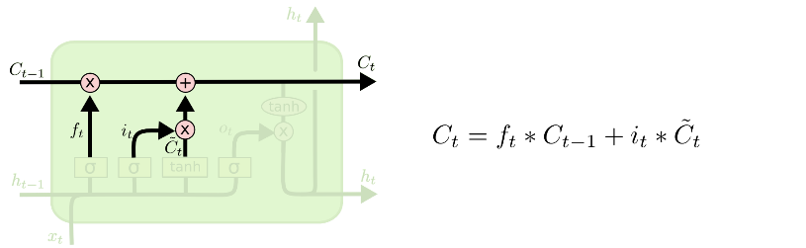

Because the equation of the cell state is a summation between the previous cell state, sigmoid function alone will only add memory and not be able to remove/forget memory. If you can only add a float number between [0, 1], that number will never be zero / turned-off / forget. This is why the input modulation gate has a **tanh** activation function. Tanh has a range of [-1, 1] and allows the cell state to forget memory.

Result from Step 1 and Step 2 are combined to form the current state shown above.

|  |  |  |
| --- | --- | --- |
| **Forget Gate** | **Input Gate** | **Current Cell State Action** |
| 0 (Closed) | 0 (Closed) | Erase the previous value |
| 1 (Open) | 0 (Closed) | Remember the previous value |
| 0 (Closed) | 1 (Open) | Overwrite the pervious value |
| 1 (Open) | 1 (Open) | Remember and add to the previous value |

**Step 3:**

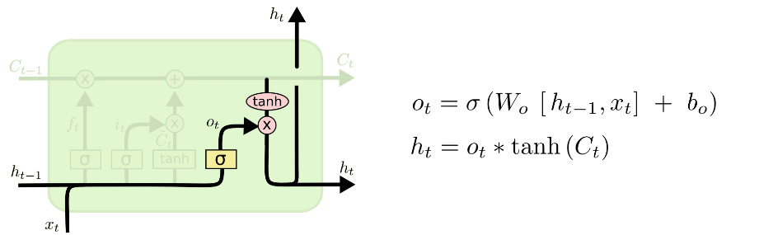

Finally, to prepare the current hidden state i.e. h_t for use in the next time step is made. h_t is based on current cell state made in Step 2 but is filtered. First the current input x_t and previous hidden state information h_t-1 are combined and fed into the sigmoid function to decide whether past information should be kept or not. Then tanh is used to scale the output from the current cell state to be between -1 and 1 and then finally multiple with the sigmoid output to produce h_t.

**Data Preparation**

The library used to implement the neural network is TensorFlow with Keras layers on top. There are 2 ways data can be prepared for neural networks before reshaping them into a 3D matrix.

1. Data should be formatted where each column corresponds to a variable.

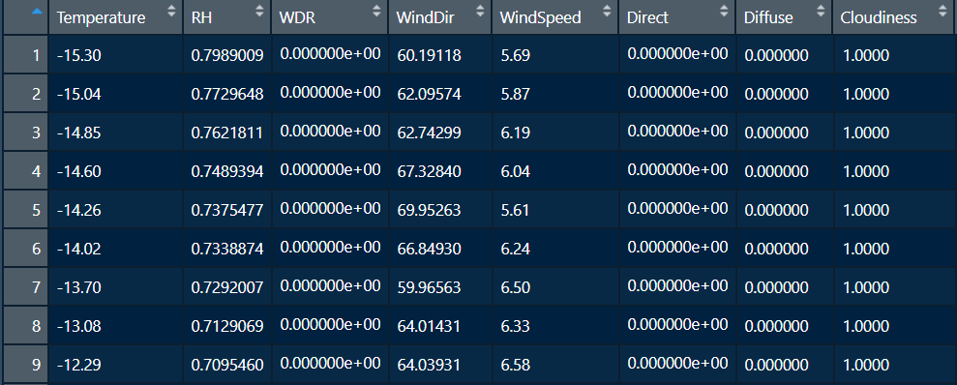

1. Lag must be applied directly to the variable.

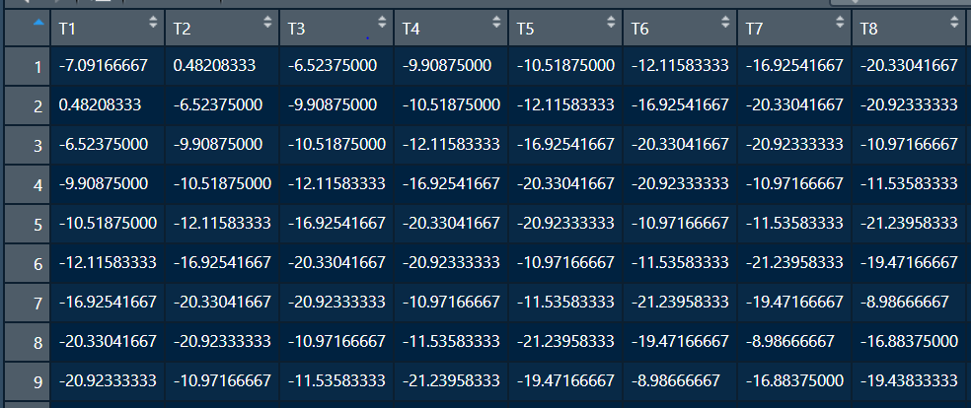

Each simulation in this report consist of 17520 hourly data points for both climate and the response. Data must be normalized before been feed into the neural network for training. This can be done with either by min/max or –mean/sd for each data point. In this report data was normalized by subtracting the mean and dividing by the standard deviation for each column of the climate data and the response. Finally, for the neural network to train on data must be arranged in a 3D array for multiple simulations. If there are 50 simulations each with 17520 values with 4 climate variables, data must be shaped in the form (17520, 50, 4) and then feed for training. For the respective response the data will be shaped as (17520, 50, 1). Data will then need to be denormalized to convert to original units for it to be compared with the actual results.

**Methodology**

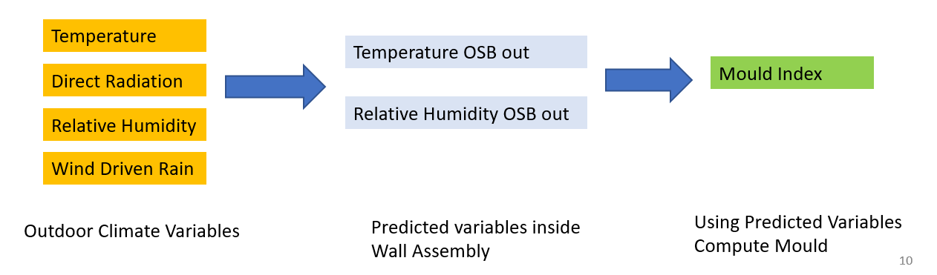

62 HAM simulations were performed using DELPHIN for Brick & Fibreboard for Ottawa City to produce Temperature and Relative Humidity on outer layer of the OSB. Each simulation consists of Average year (based on moisture index) + each year of the 31 years of Historical (1986-2016) and Future (2062-2092). Both LSTM & CNN were trained randomly on 50 selected simulation and the performance was assessed on the remaining 12 simulations.

For LSTM, the lag was implicitly defined in the data preparation phase. For temperature a lag of 48 hours was used while for relative humidity past 240 hours of used for each explanatory variable. For CNN, the lag is defined by the size of the receptive field which is defined by the hyperparameters.

**Hyperparameters Optimization**

A systematic approach was used to change one parameter at a time and monitor the performance on the validation set.

|  |  |  |  |  |  |
| --- | --- | --- | --- | --- | --- |
| LSTM | | | | | |
| Response | Neurons | Layer | Optimizer | Validation Error | Learning rate |
| T_out_OSB | 64 | 3 | Adam | 0.001 | 0.001 |
| T_out_OSB | 128 | 3 | Adam | 0.001 | 0.001 |
| T_out_OSB | 256 | 3 | Adam | 0.001 | 0.001 |
| RH_out_OSB | 64 | 3 | Adam | 0.09 | 0.001 |
| RH_out_OSB | 128 | 3 | Adam | 0.1 | 0.001 |
| RH_out_OSB | 256 | 3 | Adam | 0.09 | 0.001 |
| RH_out_OSB | 64 | 3 | RMSProp | 0.09 | 0.001 |
| RH_out_OSB | 128 | 3 | RMSProp | 0.09 | 0.001 |
| RH_out_OSB | 256 | 3 | RMSProp | 0.1 | 0.001 |

|  |  |  |  |  |  |  |  |  |
| --- | --- | --- | --- | --- | --- | --- | --- | --- |
| CNN | | | | | | | | |
| Response | # Residual Filters | Size of receptive field | # Gate filters | Gate Filter width | Stacks | Layers | # penultimate  filters | Validation Error |
| RH_out_OSB | 16 | 46 | 128 | 4 | 3 | 4 | 64 | 0.18 |
| RH_out_OSB | 16 | 94 | 128 | 4 | 3 | 5 | 64 | 0.17 |
| RH_out_OSB | 32 | 94 | 128 | 4 | 3 | 5 | 64 | 0.17 |
| RH_out_OSB | 32 | 94 | 128 | 4 | 3 | 5 | 64 | 0.17 |
| RH_out_OSB | 32 | 46 | 128 | 4 | 3 | 4 | 32 | 0.17 |
| RH_out_OSB | 32 | 190 | 128 | 4 | 3 | 7 | 32 | 0.20 |
| RH_out_OSB | 32 | 94 | 128 | 4 | 2 | 5 | 16 | 0.165 |
| RH_out_OSB | 16 | 46 | 128 | 4 | 2 | 4 | 16 | 0.6 |
| T_out_OSB | 64 | 94 | 128 | 7 | 3 | 5 | 64 | 0.01 |

**Performance Stats & Graphs**

**Brick**

**Temperature**

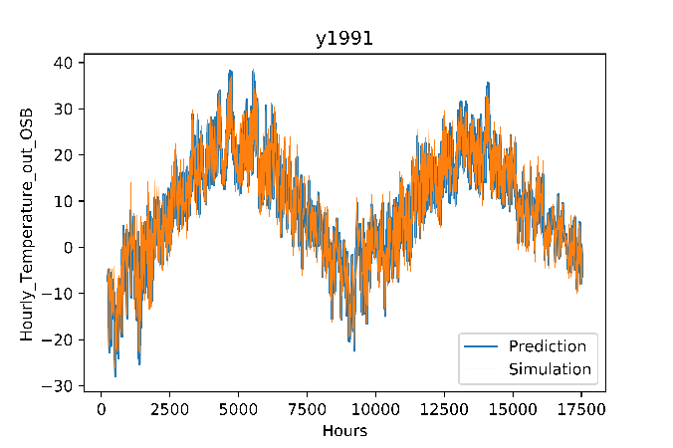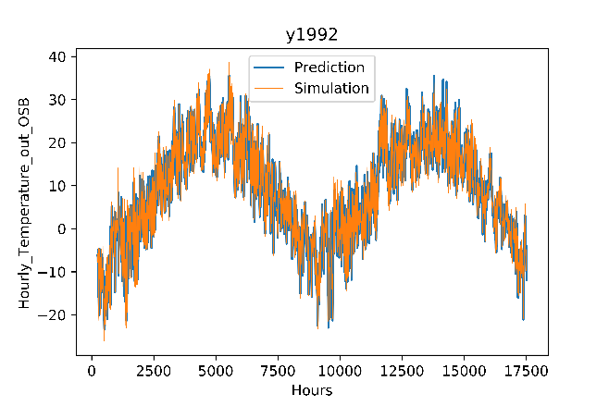

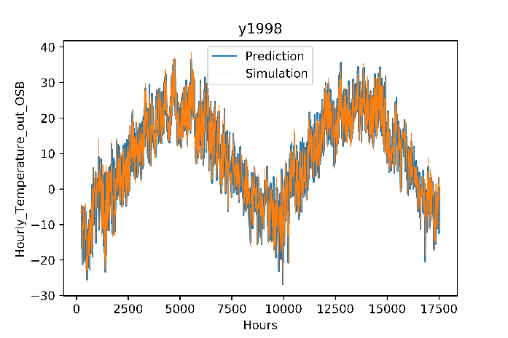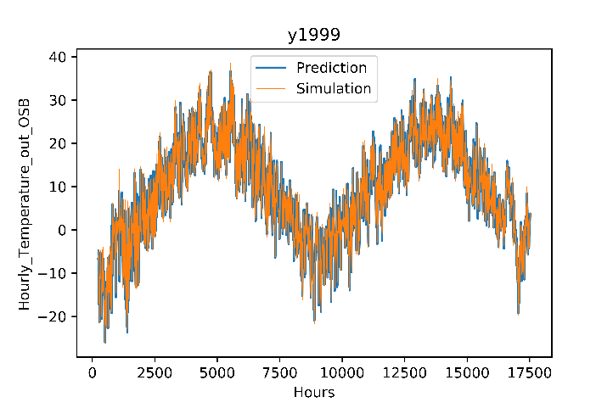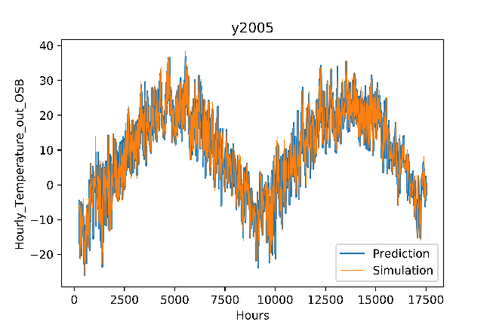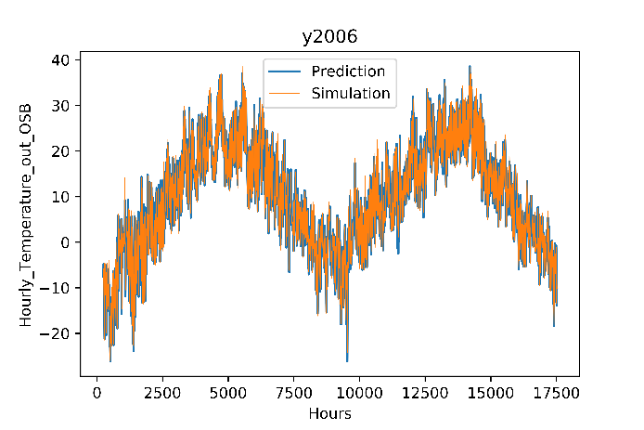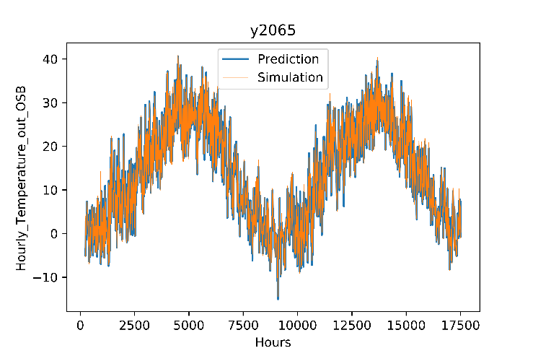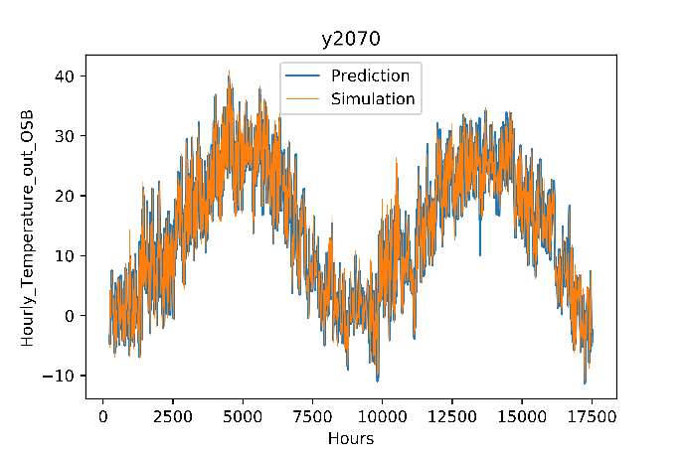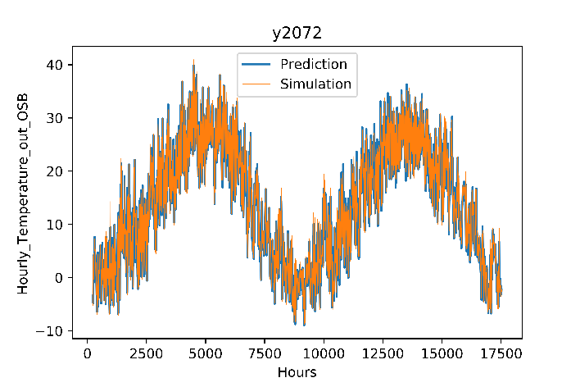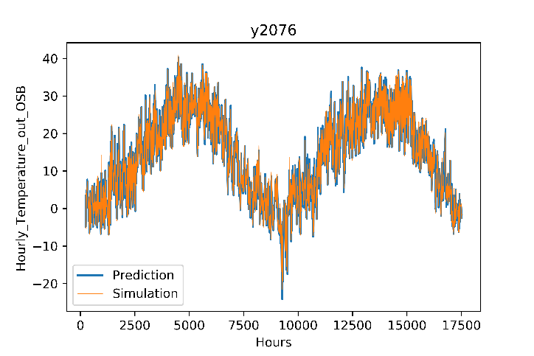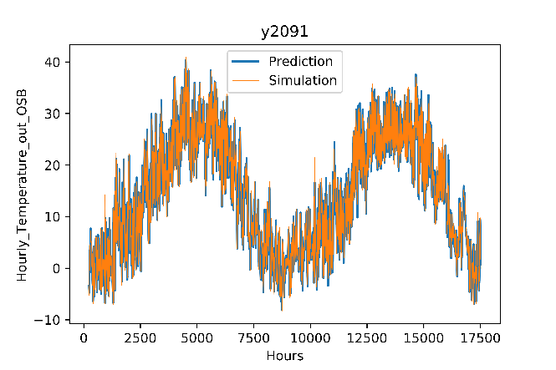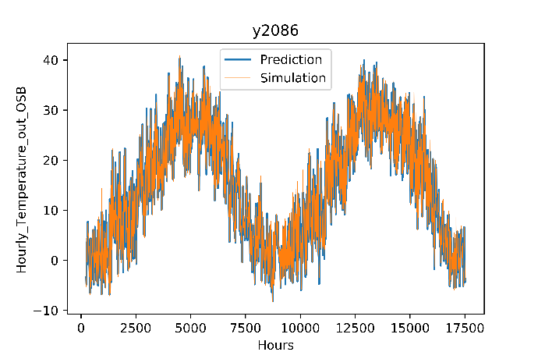

**Relative Humidity**

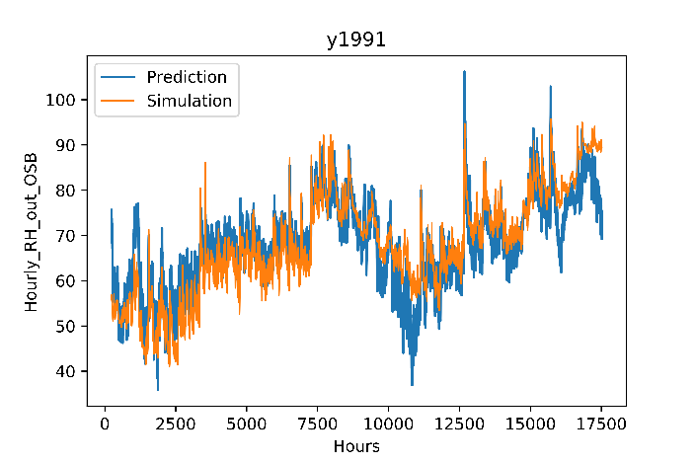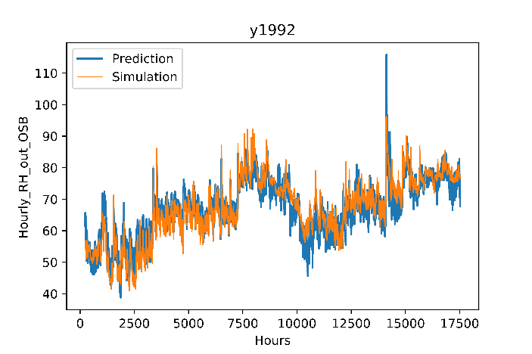

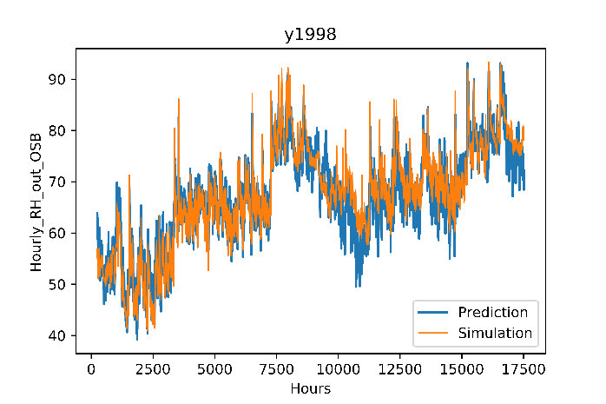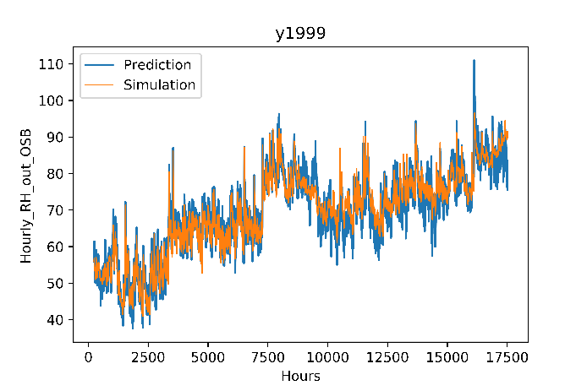

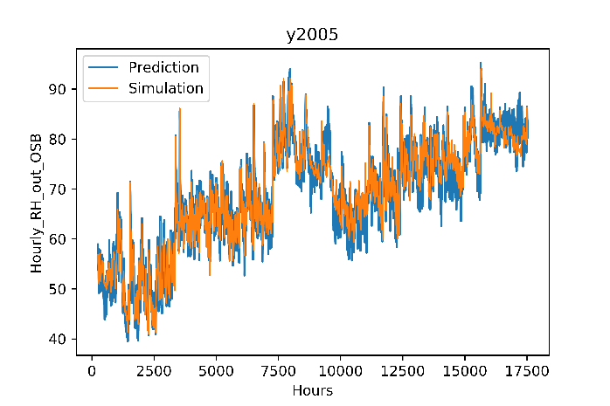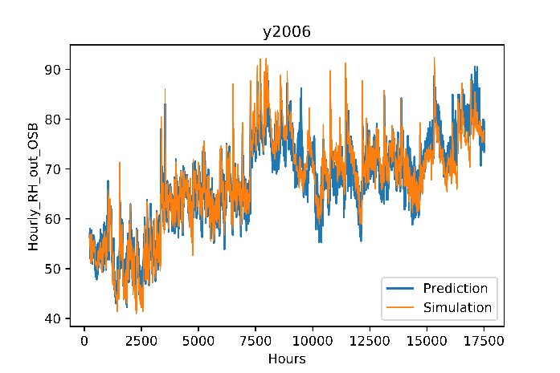

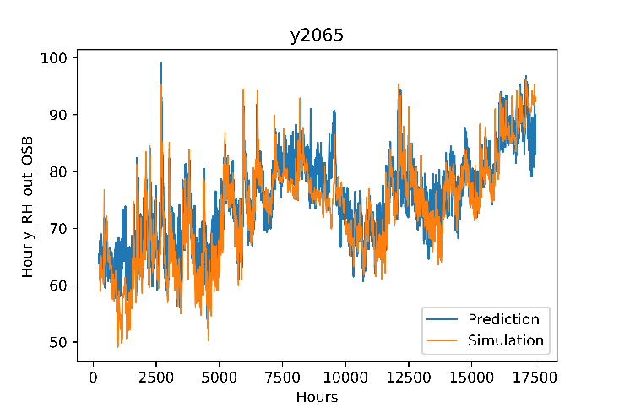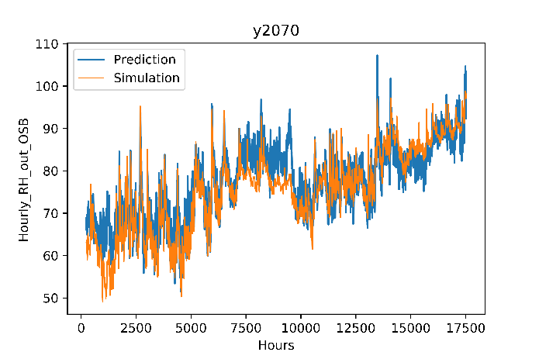

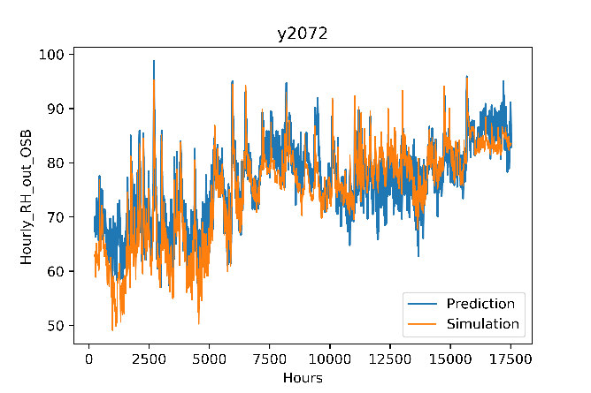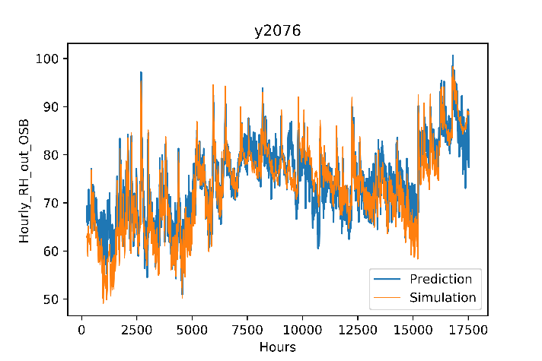

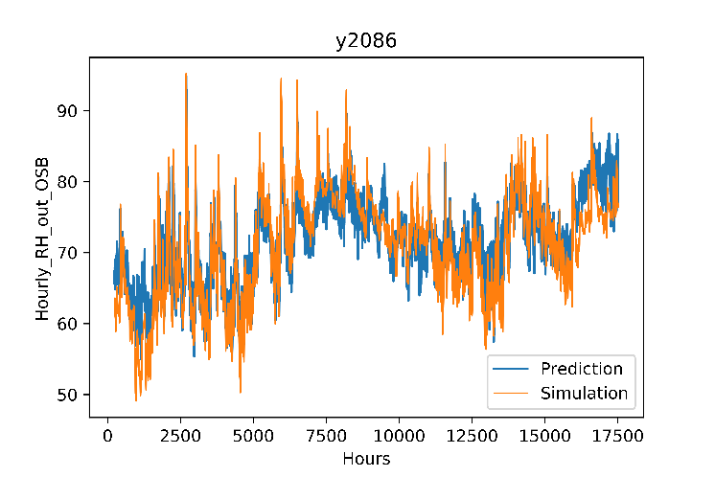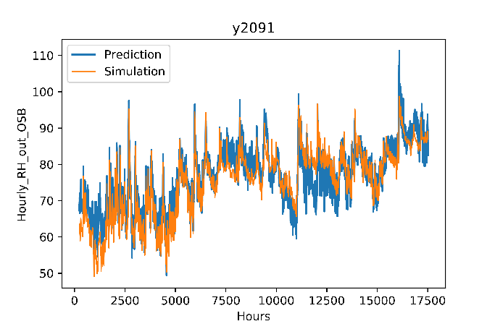

**Mould Index**

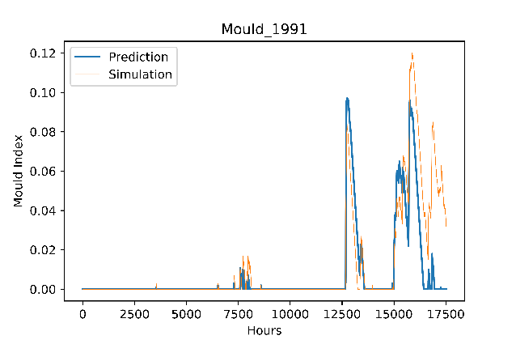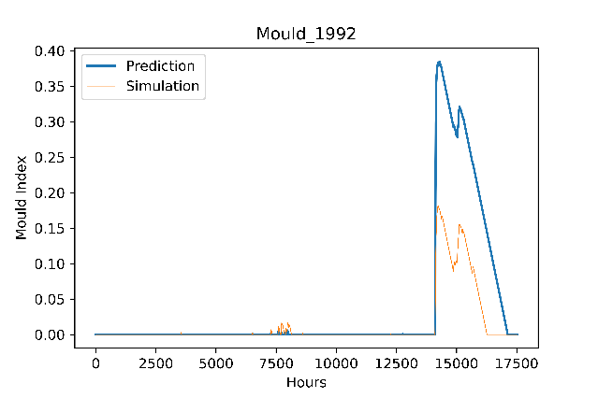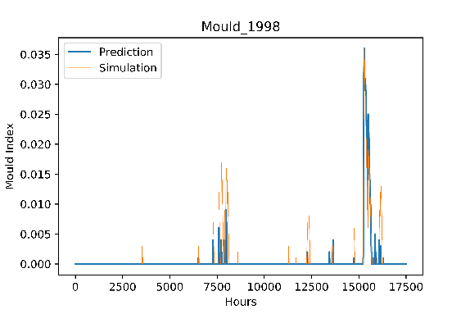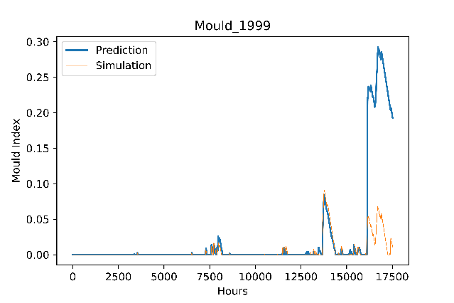

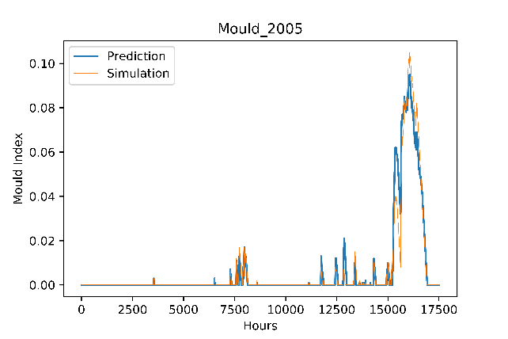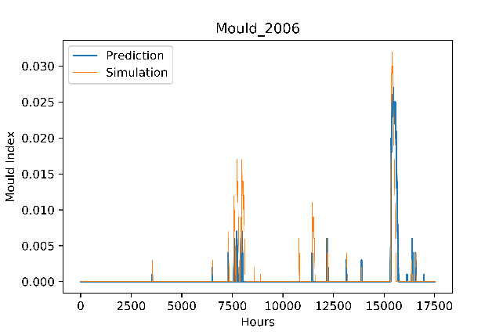

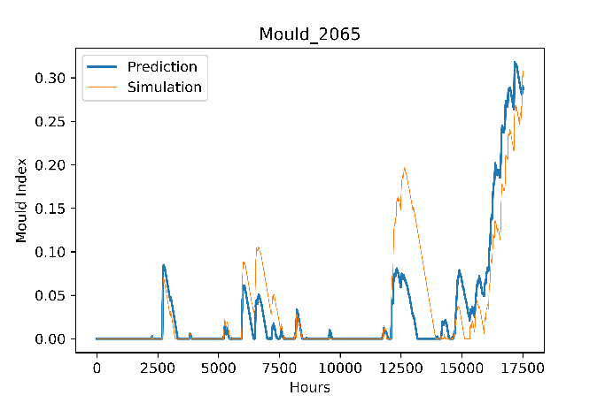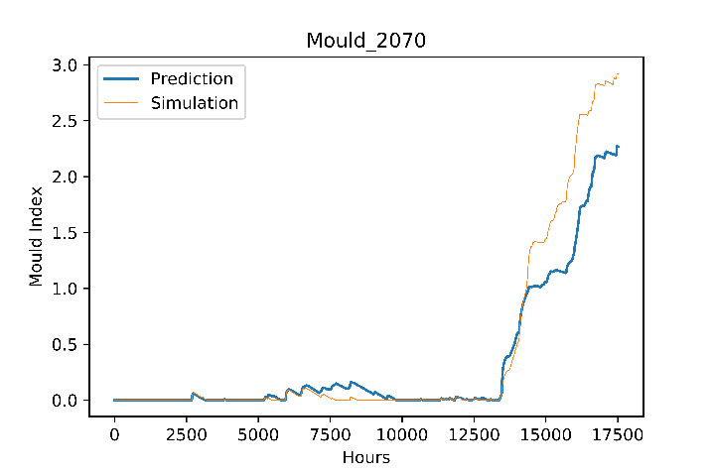

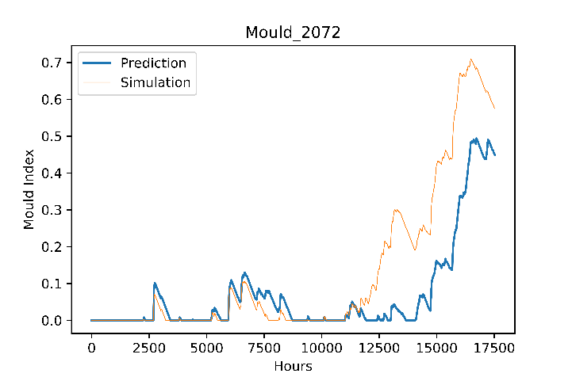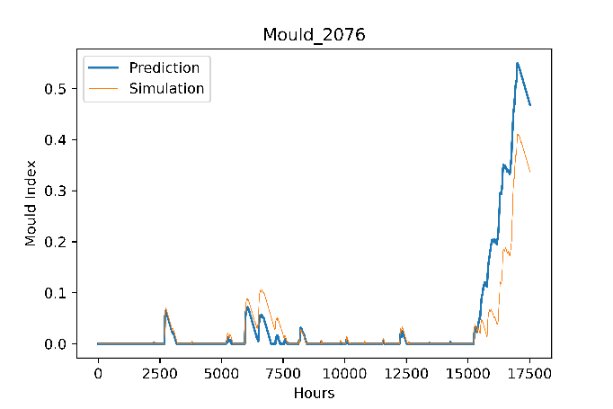

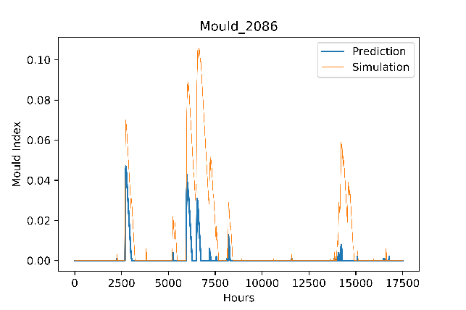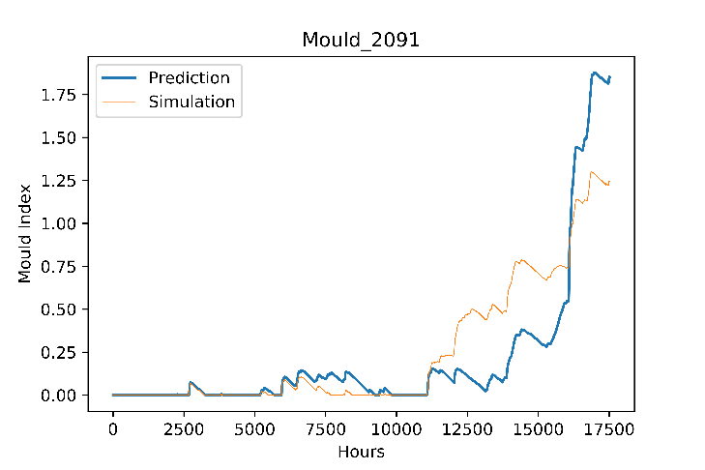

**Fibreboard**

**Temperature**

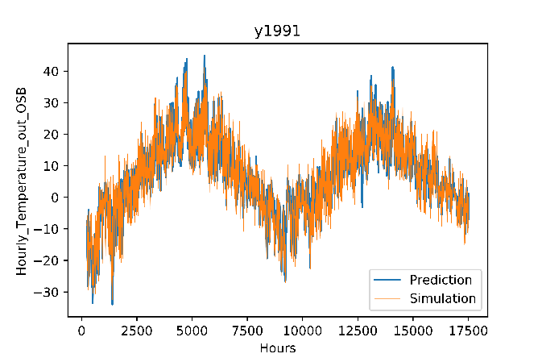 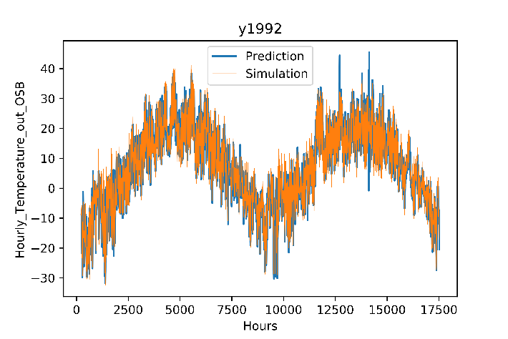

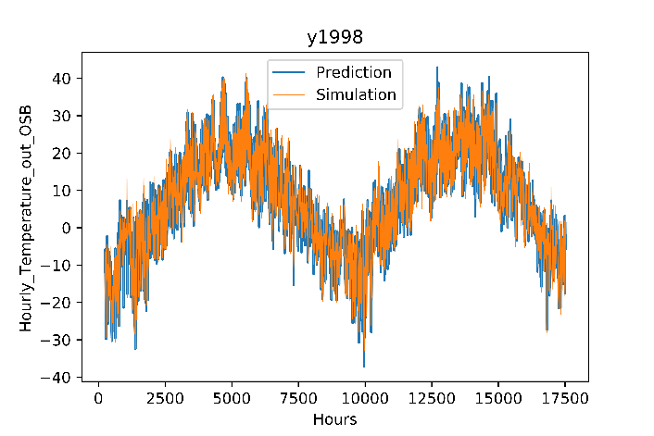 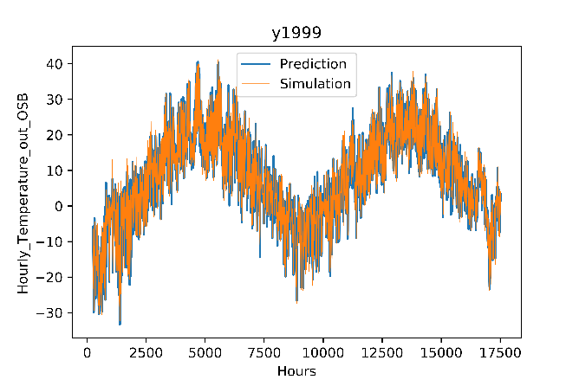

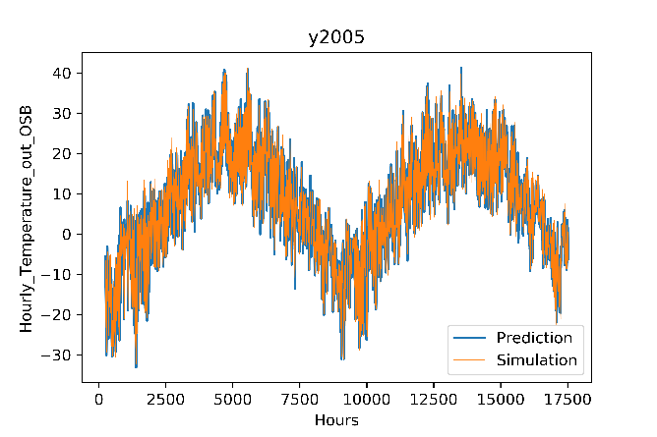 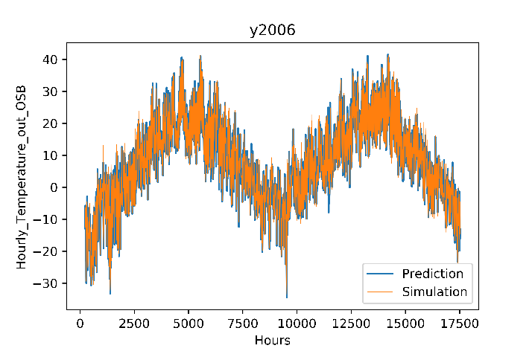

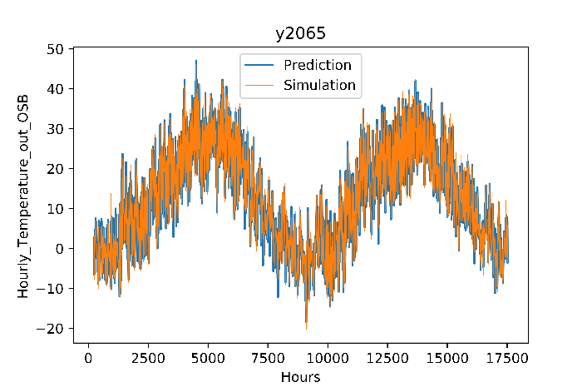 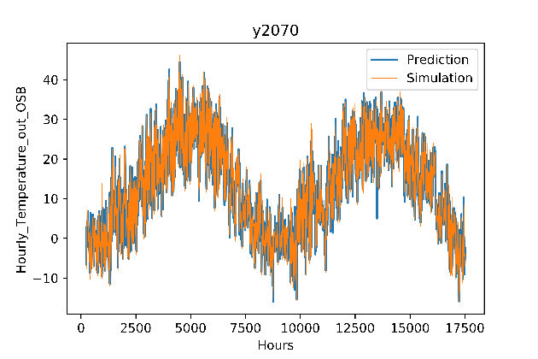

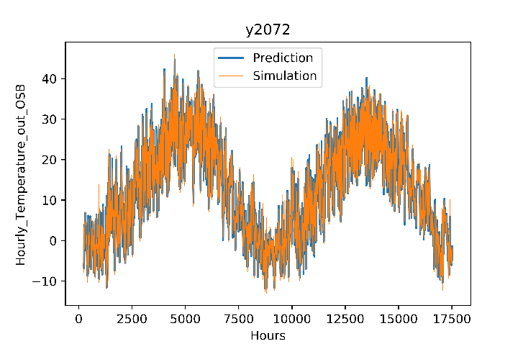 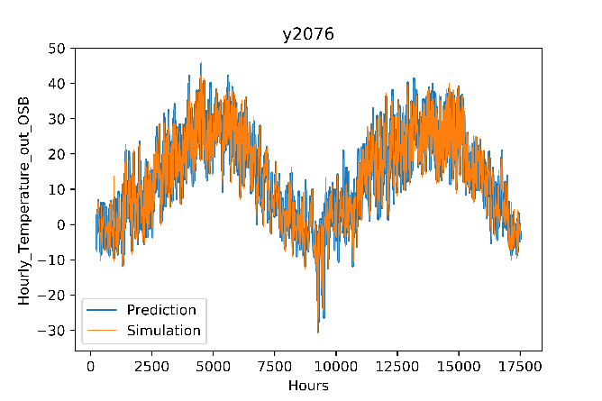

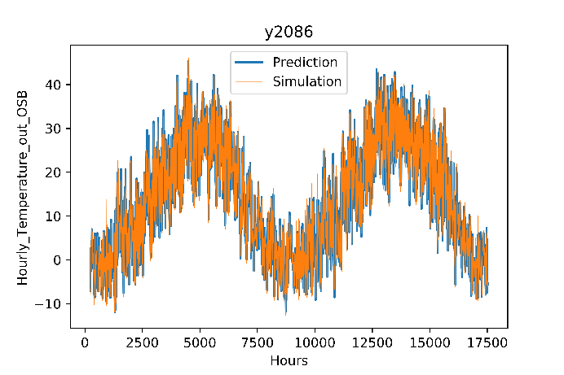 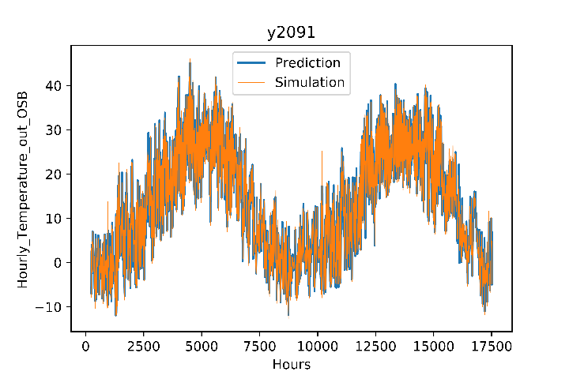

**Relative Humidity**

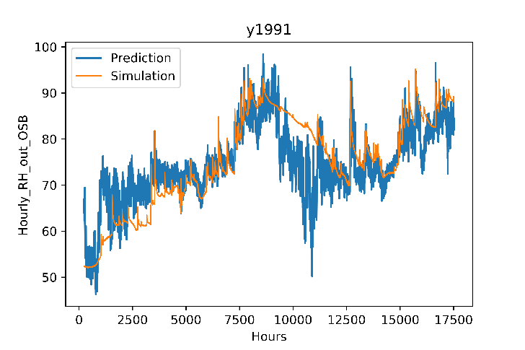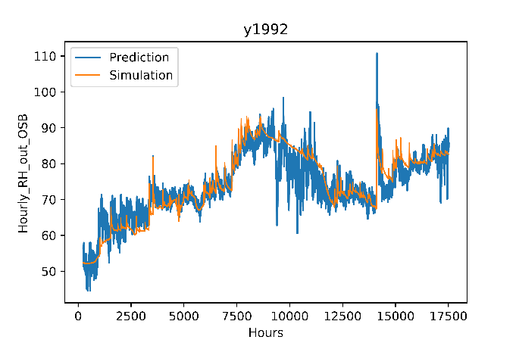

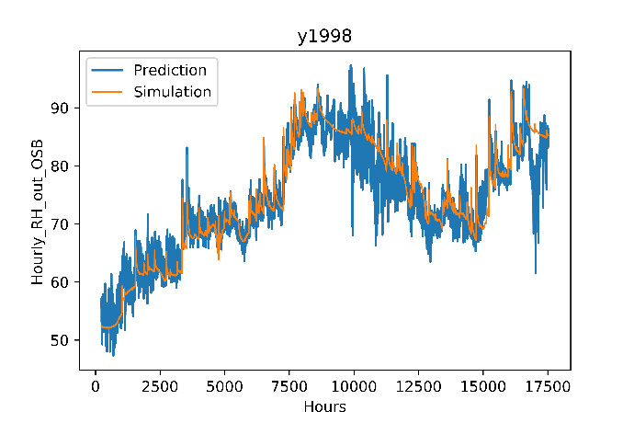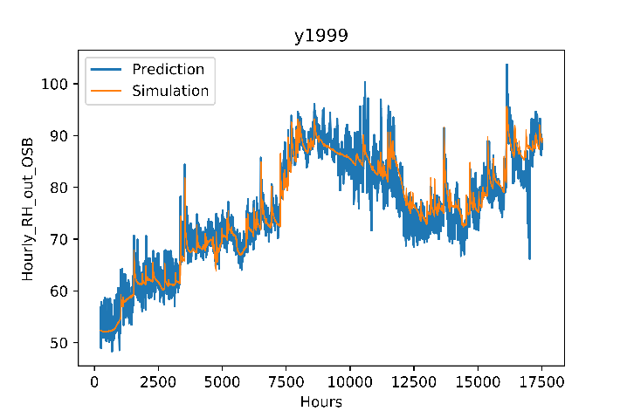

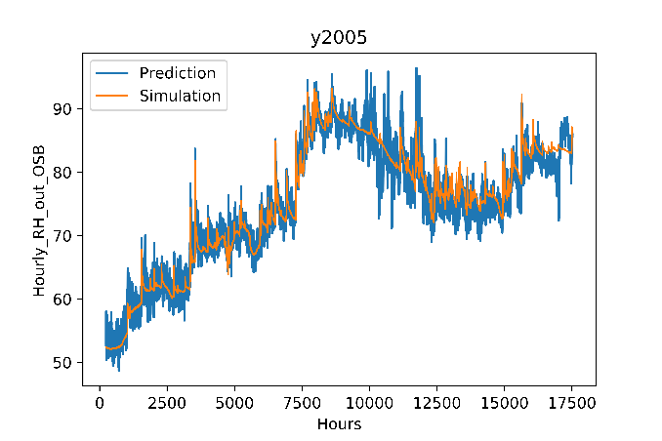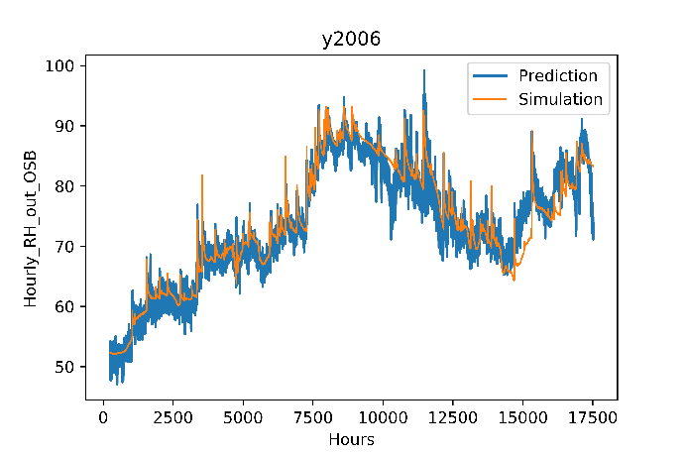

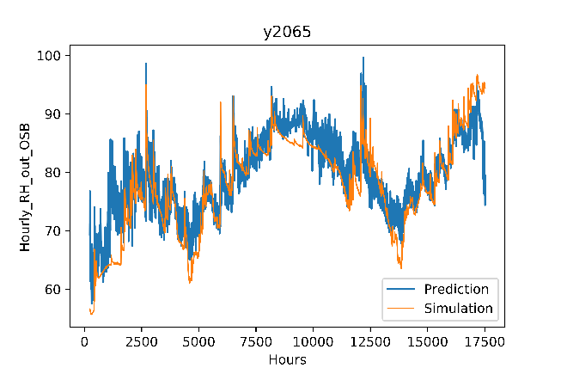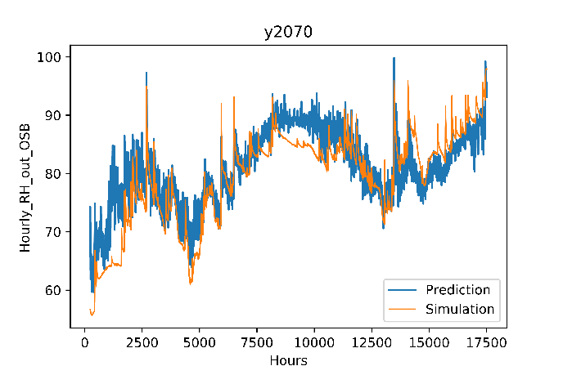

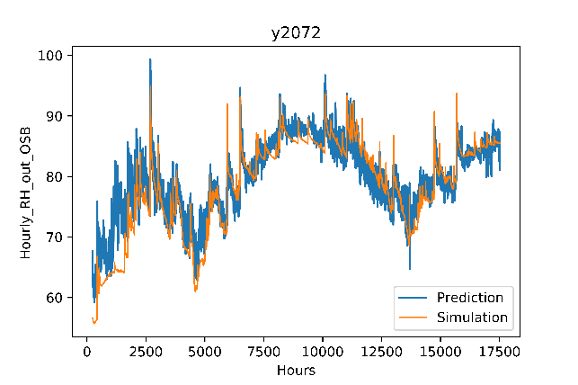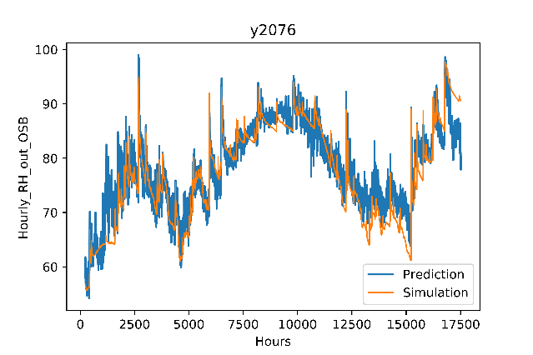

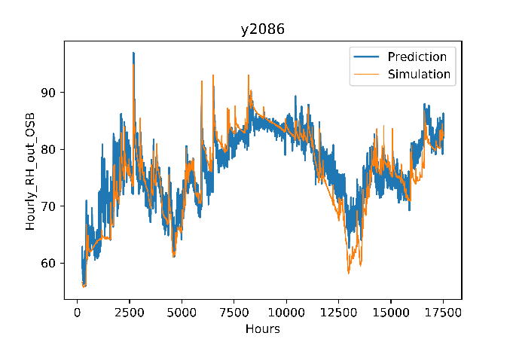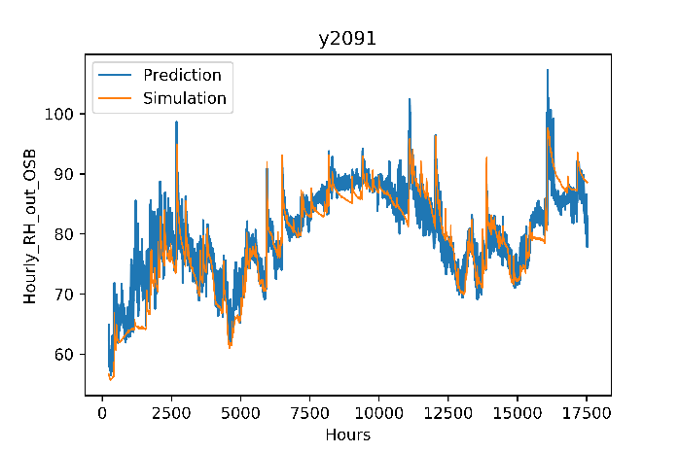

**Mould Index**

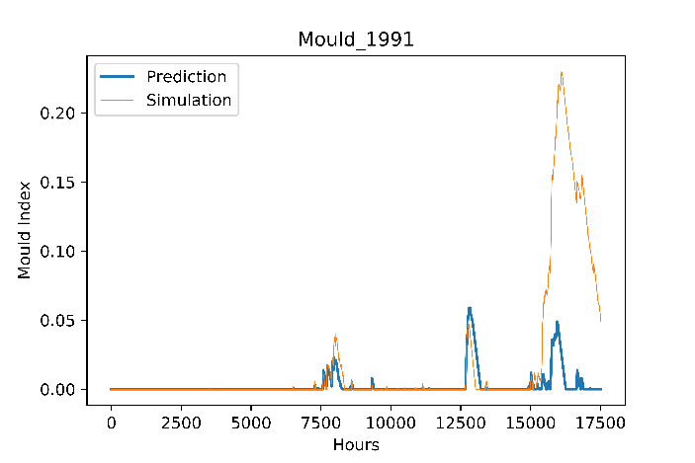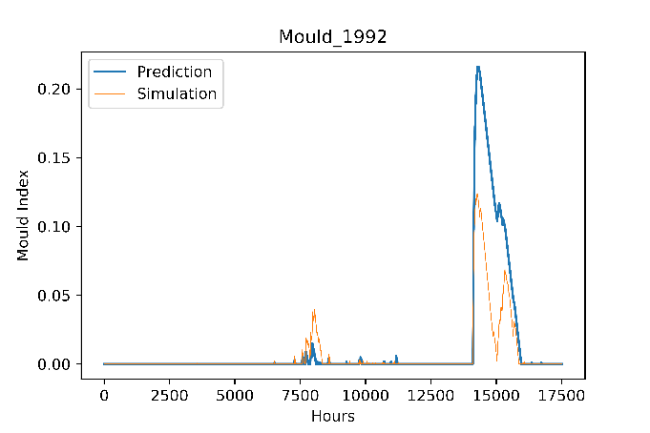

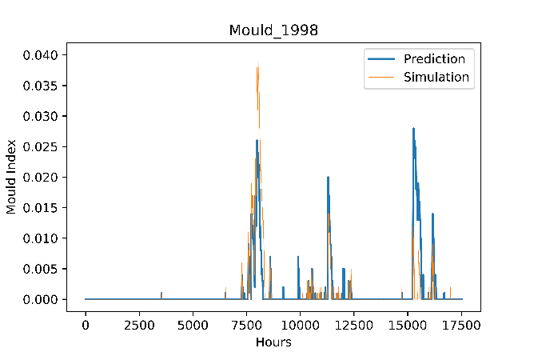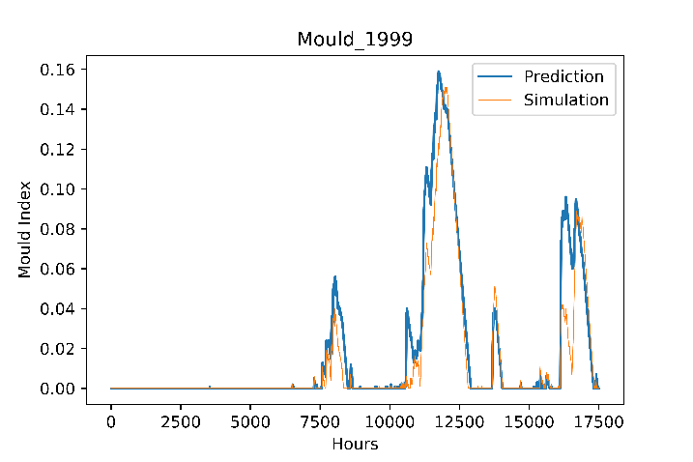

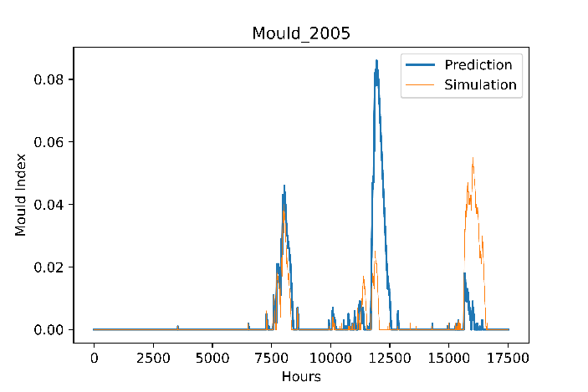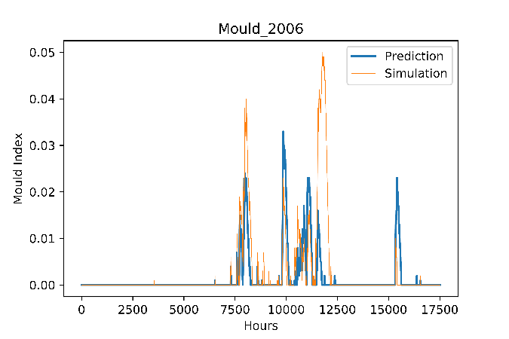

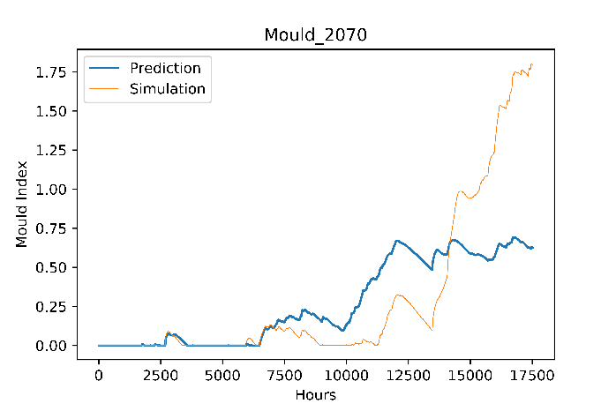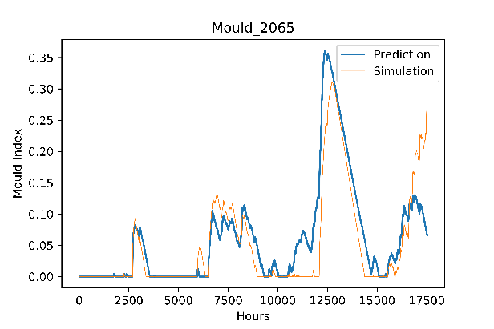

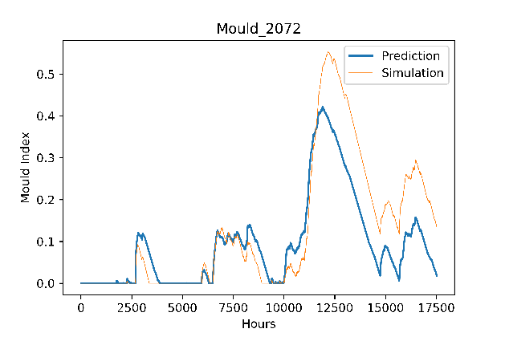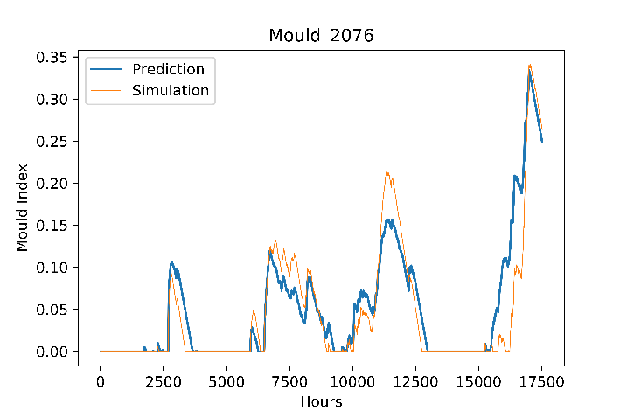

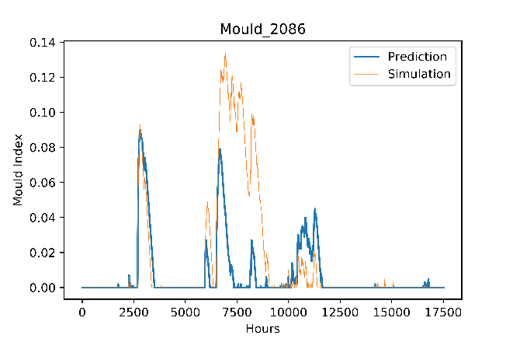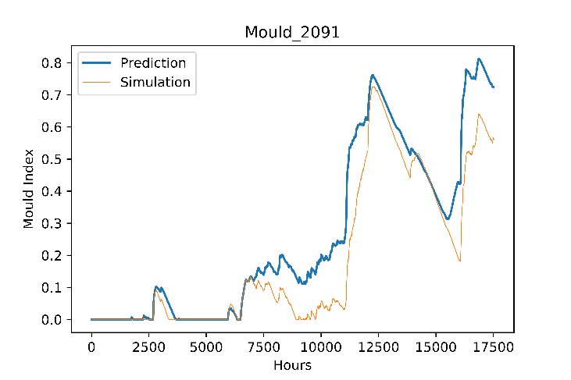

**Conclusion**

Hygrothermal simulation models such as DELPHIN, WUFI, COMSOL, etc. are commonly used to assess the durability and climate resiliency of building envelopes components. However, these models require technical knowledge and a long time to prepare, set up and run simulations, i.e., 2D simulations may take several days or weeks to complete depending on the number of years. To overcome these drawbacks, this report compares two data-driven machine learning models Long Short-Term Memory (LSTM) & Convolutional Neural Network (CNN) to compute the Mould Index on the outer layer of OSB. The idea is to construct and optimize the Neural Networks on a represented training set for a run and validate the results with the remaining cases. Results showed that LSTM was able to capture the complex, nonlinear relationship in both Temperature & Relative Humidity and thus was able to compute the Mould Index reasonably well for all test cases. The model was able to incorporate both Historical & Future Years and adapt to different cladding like Brick & Fibreboard. Additionally, the LSTM model was 4 times faster compared to traditional hygrothermal simulation (HAM) tools. Hence this approach permits reducing the time needed for simulation using traditional heat, air, and moisture simulation tools, especially when considering two- or three-dimensional simulations.